**UNIX Introduction**

**What is UNIX?**

UNIX is an operating system which was first developed in the 1960s, and has been under constant development ever since. By operating system, we mean the suite of programs which make the computer work. It is a stable, multi-user, multi-tasking system for servers, desktops and laptops.

UNIX systems also have a graphical user interface (GUI) similar to Microsoft Windows which provides an easy to use environment. However, knowledge of UNIX is required for operations which aren't covered by a graphical program, or for when there is no windows interface available, for example, in a telnet session.

**Types of UNIX**

There are many different versions of UNIX, although they share common similarities. The most popular varieties of UNIX are Sun Solaris, GNU/Linux, and MacOS X.

Here in the School, we use Solaris on our servers and workstations, and Fedora Linux on the servers and desktop PCs.

**The UNIX operating system**

The UNIX operating system is made up of three parts; the kernel, the shell and the programs.

**The kernel**

The kernel of UNIX is the hub of the operating system: it allocates time and memory to programs and handles the filestore and communications in response to system calls.

As an illustration of the way that the shell and the kernel work together, suppose a user types rm myfile (which has the effect of removing the file **myfile**). The shell searches the filestore for the file containing the program rm, and then requests the kernel, through system calls, to execute the program rm on **myfile**. When the process rm myfile has finished running, the shell then returns the UNIX prompt % to the user, indicating that it is waiting for further commands.

**The shell**

The shell acts as an interface between the user and the kernel. When a user logs in, the login program checks the username and password, and then starts another program called the shell. The shell is a command line interpreter (CLI). It interprets the commands the user types in and arranges for them to be carried out. The commands are themselves programs: when they terminate, the shell gives the user another prompt (% on our systems).

The adept user can customise his/her own shell, and users can use different shells on the same machine. Staff and students in the school have the **tcsh shell** by default.

The tcsh shell has certain features to help the user inputting commands.

Filename Completion - By typing part of the name of a command, filename or directory and pressing the [**Tab**] key, the tcsh shell will complete the rest of the name automatically. If the shell finds more than one name beginning with those letters you have typed, it will beep, prompting you to type a few more letters before pressing the tab key again.

History - The shell keeps a list of the commands you have typed in. If you need to repeat a command, use the cursor keys to scroll up and down the list or type history for a list of previous commands.

**Files and processes**

Everything in UNIX is either a file or a process.

A process is an executing program identified by a unique PID (process identifier).

A file is a collection of data. They are created by users using text editors, running compilers etc.

Examples of files:

* a document (report, essay etc.)
* the text of a program written in some high-level programming language
* instructions comprehensible directly to the machine and incomprehensible to a casual user, for example, a collection of binary digits (an executable or binary file);
* a directory, containing information about its contents, which may be a mixture of other directories (subdirectories) and ordinary files.

**The Directory Structure**

All the files are grouped together in the directory structure. The file-system is arranged in a hierarchical structure, like an inverted tree. The top of the hierarchy is traditionally called **root** (written as a slash / )

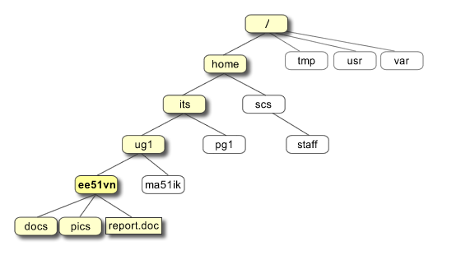

In the diagram above, we see that the home directory of the undergraduate student **"ee51vn"** contains two sub-directories (**docs** and **pics**) and a file called **report.doc**.

The full path to the file **report.doc** is **"/home/its/ug1/ee51vn/report.doc"**

**Starting an UNIX terminal**

To open an UNIX terminal window, click on the "Terminal" icon from Applications/Accessories menus. In our system you will access the server using putty.

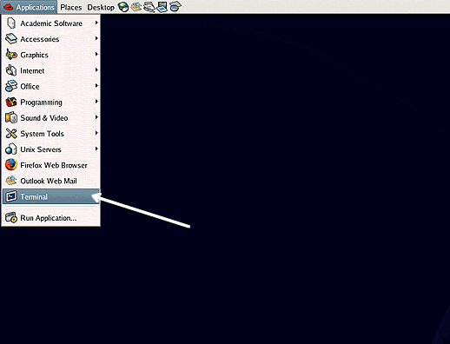

An UNIX Terminal window will then appear with a % prompt, waiting for you to start entering commands.

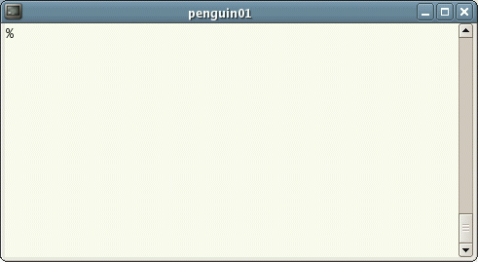

# UNIX Tutorial One

## 1.1 Listing files and directories

### ls (list)

When you first login, your current working directory is your home directory. Your home directory has the same name as your user-name, for example, **ee91ab**, and it is where your personal files and subdirectories are saved.

To find out what is in your home directory, type

% ls

The ls command ( lowercase L and lowercase S ) lists the contents of your current working directory.

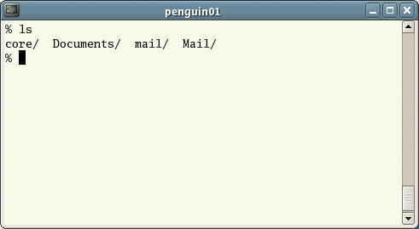

There may be no files visible in your home directory, in which case, the UNIX prompt will be returned. Alternatively, there may already be some files inserted by the System Administrator when your account was created.

ls does not, in fact, cause all the files in your home directory to be listed, but only those ones whose name does not begin with a dot (.) Files beginning with a dot (.) are known as hidden files and usually contain important program configuration information. They are hidden because you should not change them unless you are very familiar with UNIX!!!

To list all files in your home directory including those whose names begin with a dot, type

% ls -a

As you can see, ls -a lists files that are normally hidden.

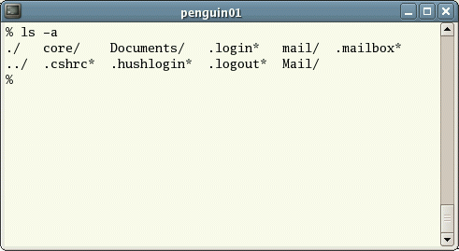

ls is an example of a command which can take options: **-a** is an example of an option. The options change the behaviour of the command. There are online manual pages that tell you which options a particular command can take, and how each option modifies the behaviour of the command. (See later in this tutorial)

## 1.2 Making Directories

### mkdir (make directory)

We will now make a subdirectory in your home directory to hold the files you will be creating and using in the course of this tutorial. To make a subdirectory called unixstuff in your current working directory type

% mkdir unixstuff

To see the directory you have just created, type

% ls

## 1.3 Changing to a different directory

### cd (change directory)

The command cd directory means change the current working directory to *'directory'*. The current working directory may be thought of as the directory you are in, i.e. your current position in the file-system tree.

To change to the directory you have just made, type

% cd unixstuff

Type ls to see the contents (which should be empty)

### Exercise 1a

Make another directory inside the **unixstuff** directory called **backups**

## 1.4 The directories . and ..

Still in the **unixstuff** directory, type

% ls -a

As you can see, in the **unixstuff** directory (and in all other directories), there are two special directories called (**.**) and (**..**)

### The current directory (.)

In UNIX, (**.**) means the current directory, so typing

% cd .

NOTE: there is a space between cd and the dot

means stay where you are (the **unixstuff** directory).

This may not seem very useful at first, but using (**.**) as the name of the current directory will save a lot of typing, as we shall see later in the tutorial.

### The parent directory (..)

(**..**) means the parent of the current directory, so typing

% cd ..

will take you one directory up the hierarchy (back to your home directory). Try it now.

Note: typing cd with no argument always returns you to your home directory. This is very useful if you are lost in the file system.

## 1.5 Pathnames

### pwd (print working directory)

Pathnames enable you to work out where you are in relation to the whole file-system. For example, to find out the absolute pathname of your home-directory, type cd to get back to your home-directory and then type

% pwd

The full pathname will look something like this -

**/home/its/ug1/ee51vn**

which means that **ee51vn** (your home directory) is in the sub-directory **ug1** (the group directory),which in turn is located in the **its** sub-directory, which is in the **home** sub-directory, which is in the top-level root directory called " */ "* .



### Exercise 1b

Use the commands cd, ls and pwd to explore the file system.

(Remember, if you get lost, type cd by itself to return to your home-directory)

## 1.6 More about home directories and pathnames

### Understanding pathnames

First type cd to get back to your home-directory, then type

% ls unixstuff

to list the conents of your unixstuff directory.

Now type

% ls backups

You will get a message like this -

backups: No such file or directory

The reason is, **backups** is not in your current working directory. To use a command on a file (or directory) not in the current working directory (the directory you are currently in), you must either cd to the correct directory, or specify its full pathname. To list the contents of your backups directory, you must type

% ls unixstuff/backups

### ~ (your home directory)

Home directories can also be referred to by the tilde **~** character. It can be used to specify paths starting at your home directory. So typing

% ls ~/unixstuff

will list the contents of your unixstuff directory, no matter where you currently are in the file system.

What do you think

% ls ~

would list?

What do you think

% ls ~/..

would list?

## Summary

|  |  |
| --- | --- |
| **Command** | **Meaning** |
| ls | list files and directories |
| ls -a | list all files and directories |
| mkdir | make a directory |
| cd *directory* | change to named directory |
| cd | change to home-directory |
| cd ~ | change to home-directory |
| cd .. | change to parent directory |
| pwd | display the path of the current directory |

# UNIX Tutorial Two

## 2.1 Copying Files

### cp (copy)

cp *file1 file2* is the command which makes a copy of **file1** in the current working directory and calls it **file2**

What we are going to do now, is to take a file stored in an open access area of the file system, and use the cp command to copy it to your unixstuff directory.

First, cd to your **unixstuff** directory.

% cd ~/unixstuff

Then at the UNIX prompt, type,

% cp ~wmorales/awkexercise/science.txt .

Note: Don't forget the dot **.** at the end. Remember, in UNIX, the dot means the current directory.

The above command means copy the file **science.txt** to the current directory, keeping the name the same.

### Exercise 2a

Create a backup of your **science.txt** file by copying it to a file called **science.bak**

## 2.2 Moving files

### mv (move)

mv *file1 file2* moves (or renames) **file1** to **file2**

To move a file from one place to another, use the mv command. This has the effect of moving rather than copying the file, so you end up with only one file rather than two.

It can also be used to rename a file, by moving the file to the same directory, but giving it a different name.

We are now going to move the file science.bak to your backup directory.

First, change directories to your unixstuff directory (can you remember how?). Then, inside the **unixstuff** directory, type

% mv science.bak backups/.

Type ls and ls backups to see if it has worked.

## 2.3 Removing files and directories

### rm (remove), rmdir (remove directory)

To delete (remove) a file, use the rm command. As an example, we are going to create a copy of the **science.txt** file then delete it.

Inside your **unixstuff** directory, type

% cp science.txt tempfile.txt  
% ls  
% rm tempfile.txt   
% ls

You can use the rmdir command to remove a directory (make sure it is empty first). Try to remove the **backups** directory. You will not be able to since UNIX will not let you remove a non-empty directory.

### Exercise 2b

Create a directory called **tempstuff** using mkdir , then remove it using the rmdir command.

## 2.4 Displaying the contents of a file on the screen

### clear (clear screen)

Before you start the next section, you may like to clear the terminal window of the previous commands so the output of the following commands can be clearly understood.

At the prompt, type

% clear

This will clear all text and leave you with the % prompt at the top of the window.

### cat (concatenate)

The command cat can be used to display the contents of a file on the screen. Type:

% cat science.txt

As you can see, the file is longer than than the size of the window, so it scrolls past making it unreadable.

### less

The command less writes the contents of a file onto the screen a page at a time. Type

% less science.txt

Press the [**space-bar**] if you want to see another page, and type [**q**] if you want to quit reading. As you can see, less is used in preference to cat for long files.

### head

The head command writes the first ten lines of a file to the screen.

First clear the screen then type

% head science.txt

Then type

% head -5 science.txt

What difference did the -5 do to the head command?

### tail

The tail command writes the last ten lines of a file to the screen.

Clear the screen and type

% tail science.txt

Q. How can you view the last 15 lines of the file?

## 2.5 Searching the contents of a file

### Simple searching using less

Using less, you can search though a text file for a keyword (pattern). For example, to search through **science.txt** for the word **'science'**, type

% less science.txt

then, still in less, type a forward slash [**/**] followed by the word to search

/science

As you can see, less finds and highlights the keyword. Type [**n**] to search for the next occurrence of the word.

### grep (don't ask why it is called grep)

grep is one of many standard UNIX utilities. It searches files for specified words or patterns. First clear the screen, then type

% grep science science.txt

As you can see, grep has printed out each line containing the word **science**.

Or has it ????

Try typing

% grep Science science.txt

The grep command is case sensitive; it distinguishes between Science and science.

To ignore upper/lower case distinctions, use the -i option, i.e. type

% grep -i science science.txt

To search for a phrase or pattern, you must enclose it in single quotes (the apostrophe symbol). For example to search for spinning top, type

% grep -i 'spinning top' science.txt

Some of the other options of grep are:

**-v** display those lines that do NOT match   
**-n** precede each matching line with the line number   
**-c** print only the total count of matched lines

Try some of them and see the different results. Don't forget, you can use more than one option at a time. For example, the number of lines without the words science or Science is

% grep -ivc science science.txt

### wc (word count)

A handy little utility is the wc command, short for word count. To do a word count on **science.txt**, type

% wc -w science.txt

To find out how many lines the file has, type

% wc -l science.txt

## Summary

|  |  |
| --- | --- |
| **Command** | **Meaning** |
| cp *file1 file2* | copy file1 and call it file2 |
| mv *file1 file2* | move or rename file1 to file2 |
| rm *file* | remove a file |
| rmdir *directory* | remove a directory |
| cat *file* | display a file |
| less *file* | display a file a page at a time |
| head *file* | display the first few lines of a file |
| tail *file* | display the last few lines of a file |
| grep *'keyword' file* | search a file for keywords |
| wc *file* | count number of lines/words/characters in file |

# UNIX Tutorial Three

## 3.1 Redirection

Most processes initiated by UNIX commands write to the standard output (that is, they write to the terminal screen), and many take their input from the standard input (that is, they read it from the keyboard). There is also the standard error, where processes write their error messages, by default, to the terminal screen.

We have already seen one use of the cat command to write the contents of a file to the screen.

Now type cat without specifying a file to read

% cat

Then type a few words on the keyboard and press the [**Return**] key.

Finally hold the [**Ctrl**] key down and press [**d**] (written as **^D** for short) to end the input.

What has happened?

If you run the cat command without specifying a file to read, it reads the standard input (the keyboard), and on receiving the 'end of file' (**^D**), copies it to the standard output (the screen).

In UNIX, we can redirect both the input and the output of commands.

## 3.2 Redirecting the Output

We use the > symbol to redirect the output of a command. For example, to create a file called **list1** containing a list of fruit, type

% cat > list1

Then type in the names of some fruit. Press [**Return**] after each one.

pear  
banana  
apple  
^D {this means press [Ctrl] and [d] to stop}

What happens is the cat command reads the standard input (the keyboard) and the > redirects the output, which normally goes to the screen, into a file called **list1**

To read the contents of the file, type

% cat list1

### Exercise 3a

Using the above method, create another file called **list2** containing the following fruit: orange, plum, mango, grapefruit. Read the contents of **list2**

### 3.2.1 Appending to a file

The form >> appends standard output to a file. So to add more items to the file **list1**, type

% cat >> list1

Then type in the names of more fruit

peach  
grape  
orange  
^D (Control D to stop)

To read the contents of the file, type

% cat list1

You should now have two files. One contains six fruit, the other contains four fruit.

We will now use the cat command to join (concatenate) **list1** and **list2** into a new file called **biglist**. Type

% cat list1 list2 > biglist

What this is doing is reading the contents of **list1** and **list2** in turn, then outputting the text to the file **biglist**

To read the contents of the new file, type

% cat biglist

## 3.3 Redirecting the Input

We use the < symbol to redirect the input of a command.

The command sort alphabetically or numerically sorts a list. Type

% sort

Then type in the names of some animals. Press [Return] after each one.

dog  
cat  
bird  
ape  
^D (control d to stop)

The output will be

ape  
bird   
cat   
dog

Using < you can redirect the input to come from a file rather than the keyboard. For example, to sort the list of fruit, type

% sort < biglist

and the sorted list will be output to the screen.

To output the sorted list to a file, type,

% sort < biglist > slist

Use cat to read the contents of the file **slist**

## 3.4 Pipes

To see who is on the system with you, type

% who

One method to get a sorted list of names is to type,

% who > names.txt  
% sort < names.txt

This is a bit slow and you have to remember to remove the temporary file called names when you have finished. What you really want to do is connect the output of the who command directly to the input of the sort command. This is exactly what pipes do. The symbol for a pipe is the vertical bar |

For example, typing

% who | sort

will give the same result as above, but quicker and cleaner.

To find out how many users are logged on, type

% who | wc -l

### Exercise 3b

Using pipes, display all lines of **list1** and **list2** containing the letter 'p', and sort the result.

[Answer available here](http://www.ee.surrey.ac.uk/Teaching/Unix/pipeanswer.html) http://www.ee.surrey.ac.uk/Teaching/Unix/pipeanswer.html

## Summary

|  |  |
| --- | --- |
| **Command** | **Meaning** |
| command > file | redirect standard output to a file |
| command >> file | append standard output to a file |
| command < file | redirect standard input from a file |
| command1 | command2 | pipe the output of command1 to the input of command2 |
| cat file1 file2 > file0 | concatenate file1 and file2 to file0 |
| sort | sort data |
| who | list users currently logged in |

# UNIX Tutorial Four

## 4.1 Wildcards

### The * wildcard

The character **\*** is called a wildcard, and will match against none or more character(s) in a file (or directory) name. For example, in your **unixstuff** directory, type

% ls list*

This will list all files in the current directory starting with **list....**

Try typing

% ls *list

This will list all files in the current directory ending with **....list**

### The ? wildcard

The character ? will match exactly one character.  
So **?ouse** will match files like **house** and **mouse**, but not **grouse**.   
Try typing

% ls ?list

## 4.2 Filename conventions

We should note here that a directory is merely a special type of file. So the rules and conventions for naming files apply also to directories.

In naming files, characters with special meanings such as **/ * & %** , should be avoided. Also, avoid using spaces within names. The safest way to name a file is to use only alphanumeric characters, that is, letters and numbers, together with _ (underscore) and . (dot).

|  |  |
| --- | --- |
| **Good filenames** | **Bad filenames** |
| project.txt | project |
| my_big_program.c | my big program.c |
| fred_dave.doc | fred & dave.doc |

File names conventionally start with a lower-case letter, and may end with a dot followed by a group of letters indicating the contents of the file. For example, all files consisting of C code may be named with the ending **.c**, for example, **prog1.c** . Then in order to list all files containing C code in your home directory, you need only type ls *.c in that directory.

## 4.3 Getting Help

### On-line Manuals

There are on-line manuals which gives information about most commands. The manual pages tell you which options a particular command can take, and how each option modifies the behaviour of the command. Type man *command* to read the manual page for a particular command.

For example, to find out more about the **wc** (word count) command, type

% man wc

Alternatively

% whatis wc

gives a one-line description of the command, but omits any information about options etc.

### Apropos

When you are not sure of the exact name of a command,

% apropos keyword

will give you the commands with keyword in their manual page header. For example, try typing

% apropos copy

## Summary

|  |  |
| --- | --- |
| **Command** | **Meaning** |
| * | match any number of characters |
| ? | match one character |
| man command | read the online manual page for a command |
| whatis command | brief description of a command |
| apropos keyword | match commands with keyword in their man pages |

**UNIX Tutorial Five**

**5.1 File system security (access rights)**

In your **unixstuff** directory, type

% ls -l (l for long listing!)

You will see that you now get lots of details about the contents of your directory, similar to the example below.

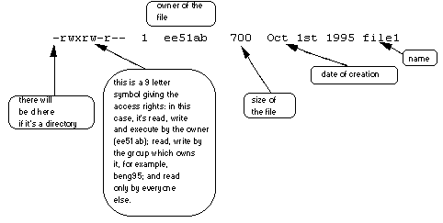

Each file (and directory) has associated access rights, which may be found by typing ls -l. Also, ls -lg gives additional information as to which group owns the file (beng95 in the following example):

-rwxrw-r-- 1 ee51ab beng95 2450 Sept29 11:52 file1

In the left-hand column is a 10 symbol string consisting of the symbols d, r, w, x, -, and, occasionally, s or S. If d is present, it will be at the left hand end of the string, and indicates a directory: otherwise - will be the starting symbol of the string.

The 9 remaining symbols indicate the permissions, or access rights, and are taken as three groups of 3.

* The left group of 3 gives the file permissions for the user that owns the file (or directory) (ee51ab in the above example);
* the middle group gives the permissions for the group of people to whom the file (or directory) belongs (eebeng95 in the above example);
* the rightmost group gives the permissions for all others.

The symbols r, w, etc., have slightly different meanings depending on whether they refer to a simple file or to a directory.

**Access rights on files.**

* r (or -), indicates read permission (or otherwise), that is, the presence or absence of permission to read and copy the file
* w (or -), indicates write permission (or otherwise), that is, the permission (or otherwise) to change a file
* x (or -), indicates execution permission (or otherwise), that is, the permission to execute a file, where appropriate

**Access rights on directories.**

* r allows users to list files in the directory;
* w means that users may delete files from the directory or move files into it;
* x means the right to access files in the directory. This implies that you may read files in the directory provided you have read permission on the individual files.

So, in order to read a file, you must have execute permission on the directory containing that file, and hence on any directory containing that directory as a subdirectory, and so on, up the tree.

**Some examples**

|  |  |
| --- | --- |
| -rwxrwxrwx | a file that everyone can read, write and execute (and delete). |
| -rw------- | a file that only the owner can read and write - no-one else  can read or write and no-one has execution rights (e.g. your  mailbox file). |

**5.2 Changing access rights**

**chmod (changing a file mode)**

Only the owner of a file can use chmod to change the permissions of a file. The options of chmod are as follows

|  |  |
| --- | --- |
| **Symbol** | **Meaning** |
| u | user |
| g | group |
| o | other |
| a | all |
| r | read |
| w | write (and delete) |
| x | execute (and access directory) |
| + | add permission |
| - | take away permission |

For example, to remove read write and execute permissions on the file **biglist** for the group and others, type

% chmod go-rwx biglist

This will leave the other permissions unaffected.

To give read and write permissions on the file **biglist** to all,

% chmod a+rw biglist

**Exercise 5a**

Try changing access permissions on the file **science.txt** and on the directory **backups**

Use ls -l to check that the permissions have changed.

**5.3 Processes and Jobs <<<<<<<<<<<< SKIP FOR NOW**

A process is an executing program identified by a unique PID (process identifier). To see information about your processes, with their associated PID and status, type

% ps

A process may be in the foreground, in the background, or be suspended. In general the shell does not return the UNIX prompt until the current process has finished executing.

Some processes take a long time to run and hold up the terminal. Backgrounding a long process has the effect that the UNIX prompt is returned immediately, and other tasks can be carried out while the original process continues executing.

**Running background processes**

To background a process, type an **&** at the end of the command line. For example, the command sleep waits a given number of seconds before continuing. Type

% sleep 10

This will wait 10 seconds before returning the command prompt %. Until the command prompt is returned, you can do nothing except wait.

To run sleep in the background, type

% sleep 10 &

[1] 6259

The **&** runs the job in the background and returns the prompt straight away, allowing you do run other programs while waiting for that one to finish.

The first line in the above example is typed in by the user; the next line, indicating job number and PID, is returned by the machine. The user is be notified of a job number (numbered from 1) enclosed in square brackets, together with a PID and is notified when a background process is finished. Backgrounding is useful for jobs which will take a long time to complete.

**Backgrounding a current foreground process**

At the prompt, type

% sleep 1000

You can suspend the process running in the foreground by typing **^Z**, i.e.hold down the [**Ctrl**] key and type [**z**]. Then to put it in the background, type

% bg

Note: do not background programs that require user interaction e.g. vi

**5.4 Listing suspended and background processes**

When a process is running, backgrounded or suspended, it will be entered onto a list along with a job number. To examine this list, type

% jobs

An example of a job list could be

[1] Suspended sleep 1000  
[2] Running netscape  
[3] Running matlab

To restart (foreground) a suspended processes, type

% fg %*jobnumber*

For example, to restart sleep 1000, type

% fg %1

Typing fg with no job number foregrounds the last suspended process.

**5.5 Killing a process**

**kill (terminate or signal a process)**

It is sometimes necessary to kill a process (for example, when an executing program is in an infinite loop)

To kill a job running in the foreground, type **^C** (control c). For example, run

% sleep 100  
^C

To kill a suspended or background process, type

% kill %*jobnumber*

For example, run

% sleep 100 &  
% jobs

If it is job number 4, type

% kill %4

To check whether this has worked, examine the job list again to see if the process has been removed.

**ps (process status)**

Alternatively, processes can be killed by finding their process numbers (PIDs) and using kill *PID_number*

% sleep 1000 &  
% ps

PID TT S TIME COMMAND  
20077 pts/5 S 0:05 sleep 1000  
21563 pts/5 T 0:00 netscape  
21873 pts/5 S 0:25 nedit

To kill off the process **sleep 1000**, type

% kill 20077

and then type ps again to see if it has been removed from the list.

If a process refuses to be killed, uses the **-9** option, i.e. type

% kill -9 20077

Note: It is not possible to kill off other users' processes !!!

**Summary**

|  |  |
| --- | --- |
| **Command** | **Meaning** |
| ls -lag | list access rights for all files |
| chmod [*options*] *file* | change access rights for named file |
| *command* & | run command in background |
| ^C | kill the job running in the foreground |
| ^Z | suspend the job running in the foreground |
| bg | background the suspended job |
| jobs | list current jobs |
| fg %1 | foreground job number 1 |
| kill %1 | kill job number 1 |
| ps | list current processes |
| kill 26152 | kill process number 26152 |

# UNIX Tutorial Six

## Other useful UNIX commands

### quota

All students are allocated a certain amount of disk space on the file system for their personal files, usually about 100Mb. If you go over your quota, you are given 7 days to remove excess files.

To check your current quota and how much of it you have used, type

% quota -v

### df

The df command reports on the space left on the file system. For example, to find out how much space is left on the fileserver, type

% df .

### du

The du command outputs the number of kilobyes used by each subdirectory. Useful if you have gone over quota and you want to find out which directory has the most files. In your home-directory, type

% du -s *

The **-s** flag will display only a summary (total size) and the * means all files and directories.

### gzip

This reduces the size of a file, thus freeing valuable disk space. For example, type

% ls -l science.txt

and note the size of the file using ls -l . Then to compress science.txt, type

% gzip science.txt

This will compress the file and place it in a file called **science.txt.gz**

To see the change in size, type ls -l again.

To expand the file, use the gunzip command.

% gunzip science.txt.gz

### zcat

zcat will read gzipped files without needing to uncompress them first.

% zcat science.txt.gz

If the text scrolls too fast for you, pipe the output though less .

% zcat science.txt.gz | less

### file

file classifies the named files according to the type of data they contain, for example ascii (text), pictures, compressed data, etc.. To report on all files in your home directory, type

% file *

### diff

This command compares the contents of two files and displays the differences. Suppose you have a file called **file1** and you edit some part of it and save it as **file2**. To see the differences type

% diff file1 file2

Lines beginning with a **<** denotes file1, while lines beginning with a **>** denotes file2.

### find

This searches through the directories for files and directories with a given name, date, size, or any other attribute you care to specify. It is a simple command but with many options - you can read the manual by typing man find.

To search for all fies with the extention **.txt**, starting at the current directory (.) and working through all sub-directories, then printing the name of the file to the screen, type

% find . -name "*.txt" -print

To find files over 1Mb in size, and display the result as a long listing, type

% find . -size +1M -ls

### history

The C shell/bash keeps an ordered list of all the commands that you have entered. Each command is given a number according to the order it was entered.

% history (show command history list)

If you are using the C shell, you can use the exclamation character (**!**) to recall commands easily.

% !! (recall last command)

% !-3 (recall third most recent command)

% !5 (recall 5th command in list)

% !grep (recall last command starting with grep)

You can increase the size of the history buffer by typing

% set history=100

[M.Stonebank@surrey.ac.uk](http://www.ee.surrey.ac.uk/Personal/M.Stonebank/)